GitHub

Create account on GitHub

<https://github.com/>

**Download and Install**

Install Git, Notepad ++ and Git Desktop

<https://git-scm.com/download/win>

<https://notepad-plus-plus.org/downloads/v7.8.5/>

<https://desktop.github.com/>

**Working with CLI**

Every command starts with Git word

**$** git config - -global user.name “ Sk8336”

**$**git config - - global user.email “ [sk8336@live.com](mailto:sk8336@live.com)”

**$**git config - - edit - - global

**Setting Environment Variable**

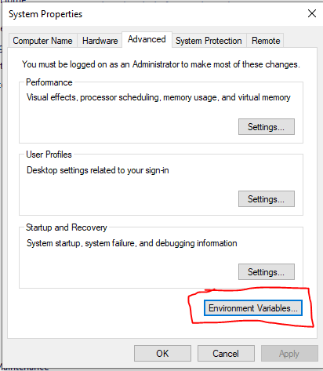

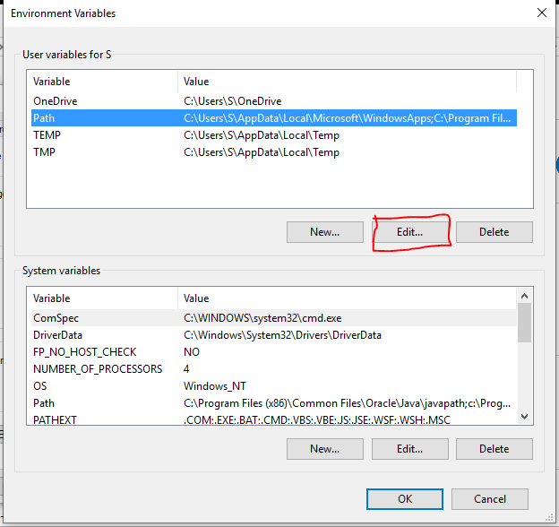

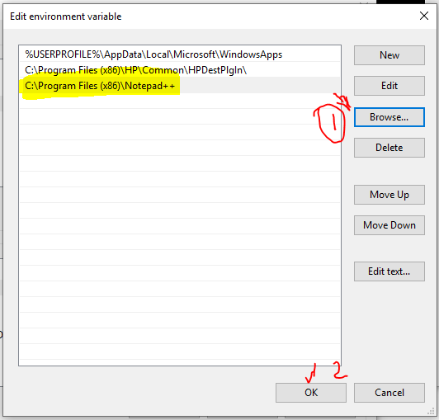

**Create a repository**

CLI—

* Go the particular directory for example **$ cd “**C:/Users/S/Desktop/MLS-C01**”**
* See the list of files like **$ls –la**
* Now create repository there $ git init DemoApp

Initialized empty Git repository in C:/Users/S/Desktop/MLS-C01/DemoApp/.git/

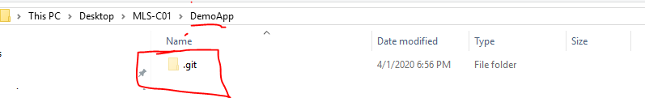

* This create a DemoApp folder and a .git hidden subfolder in the DemoApp folder and this is a local git database.

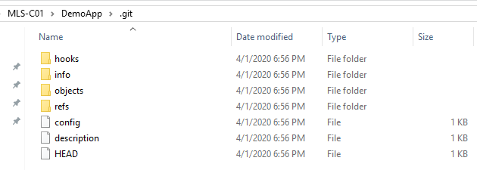

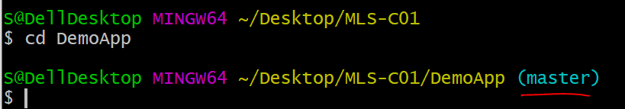

The above is master branch

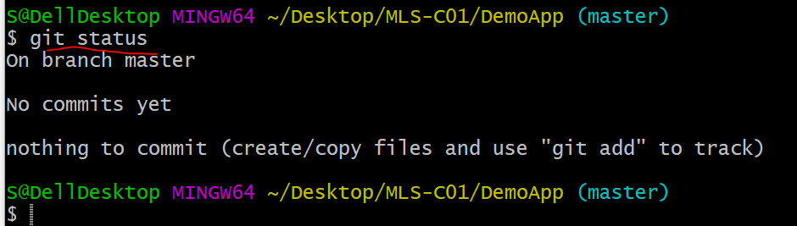

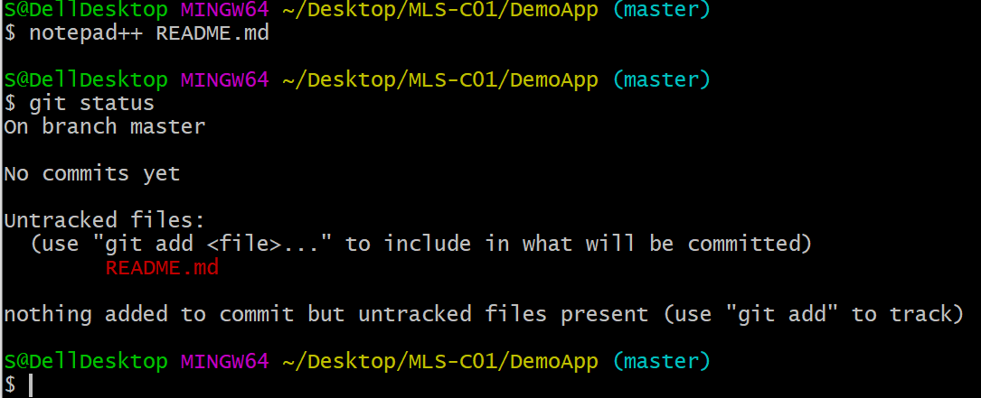

Note: In the notepad++ write **#hello world** then save and close.

Here status is changes see above

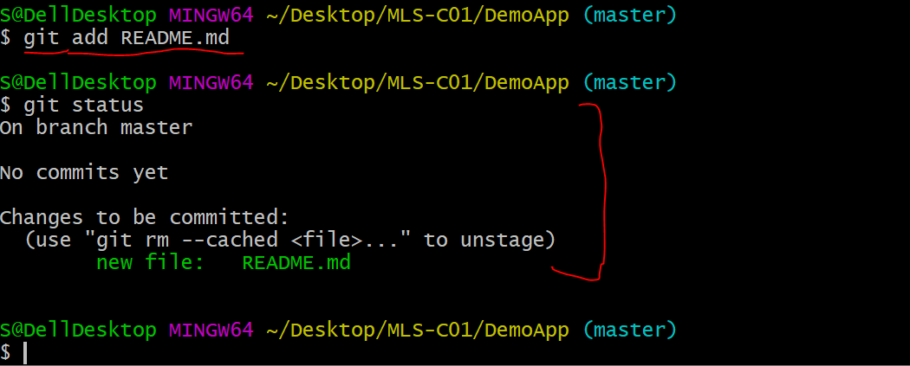

Readme is green

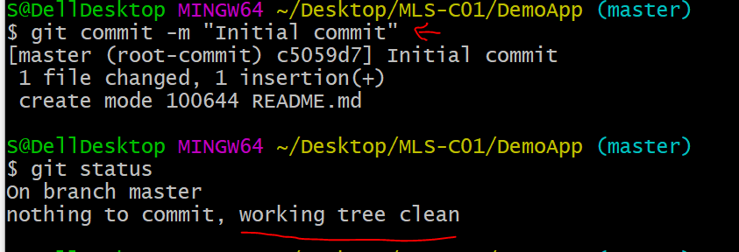

I copied two files and see below how I commit it

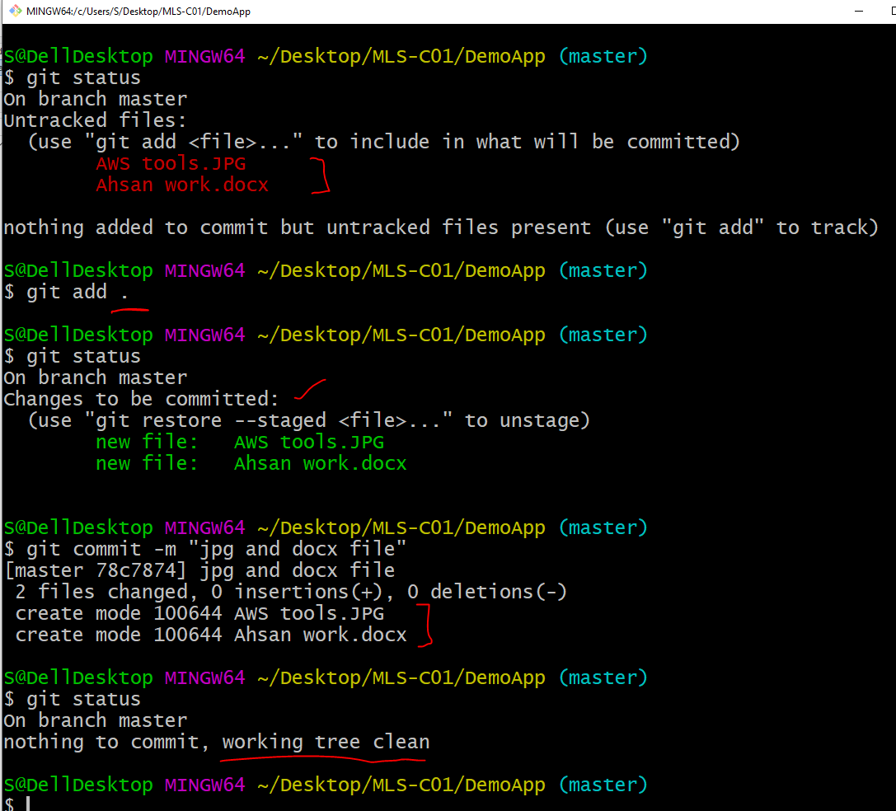

**What GitHub Can do for you (Link local repo to remote repo)**

Copy the highlighted one:

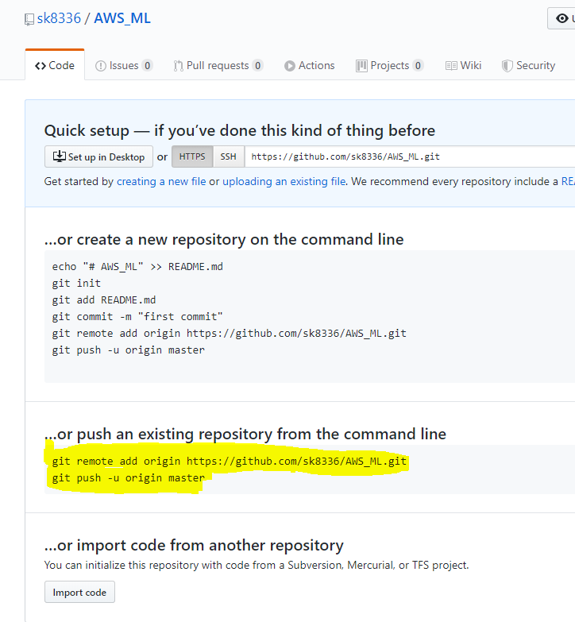

Check the remote connection, copy/paste add original. Again check the remote one then push local repo.

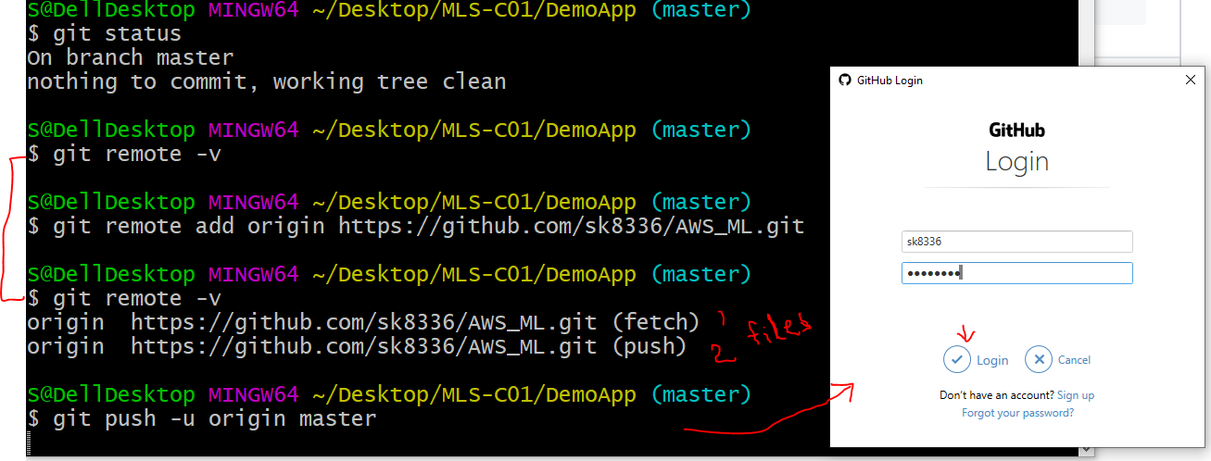

This creates empty branch and setup track branch.

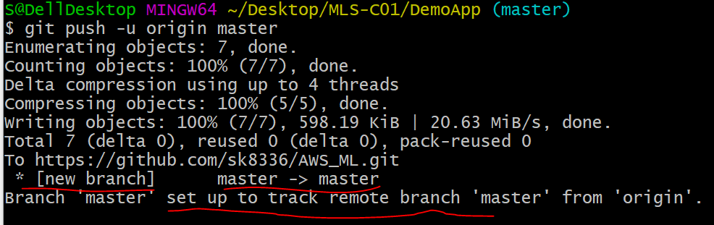

See the updated files on remote location.

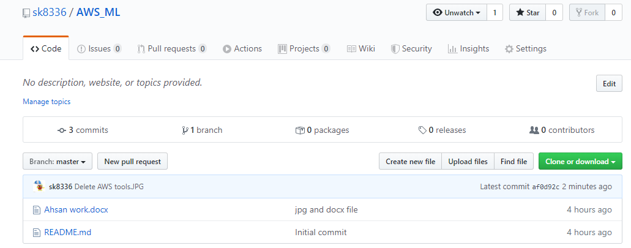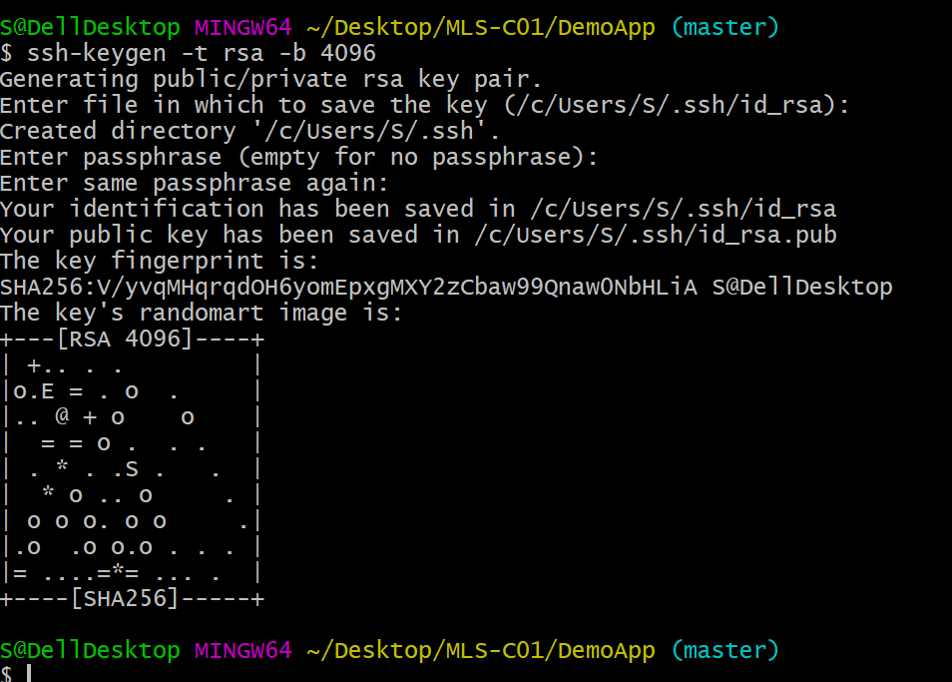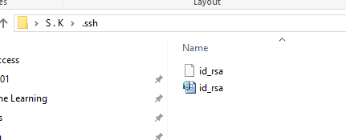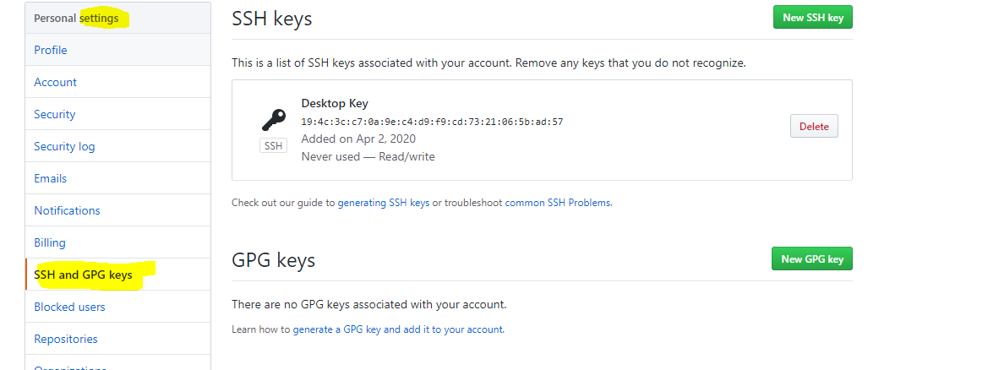

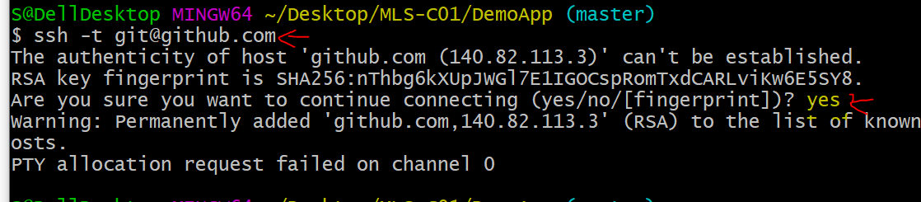

**Markdown Special Files are**

* README.md
* LICENSE.md
* Contributors.md - person who contributes in the projet
* SUPPORT
* CODE_OF_CONDUCTS

Note # is the H1 and ## is H2 heading

<https://daringfireball.net/projects/markdown/syntax>

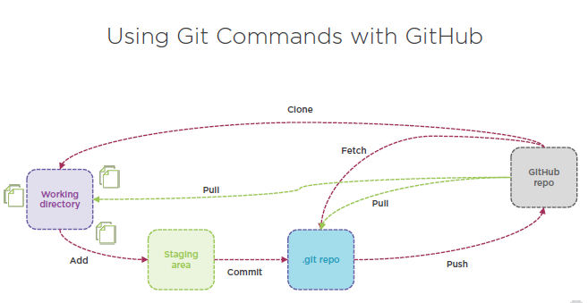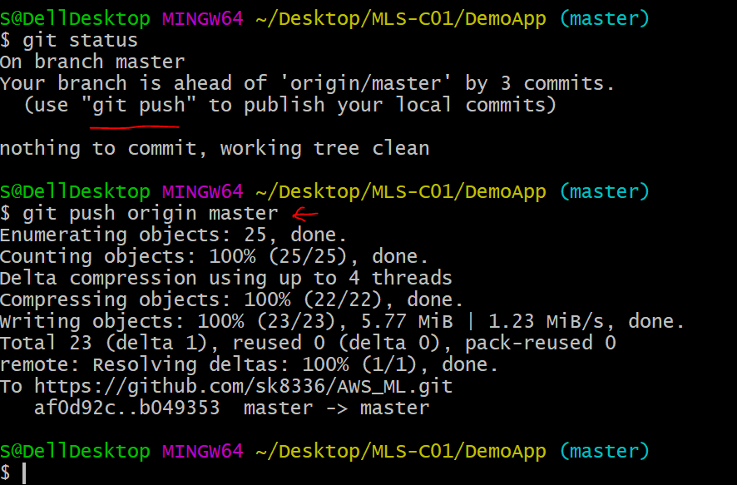

Branches, Merging and Pull Request

Diverging from main development line

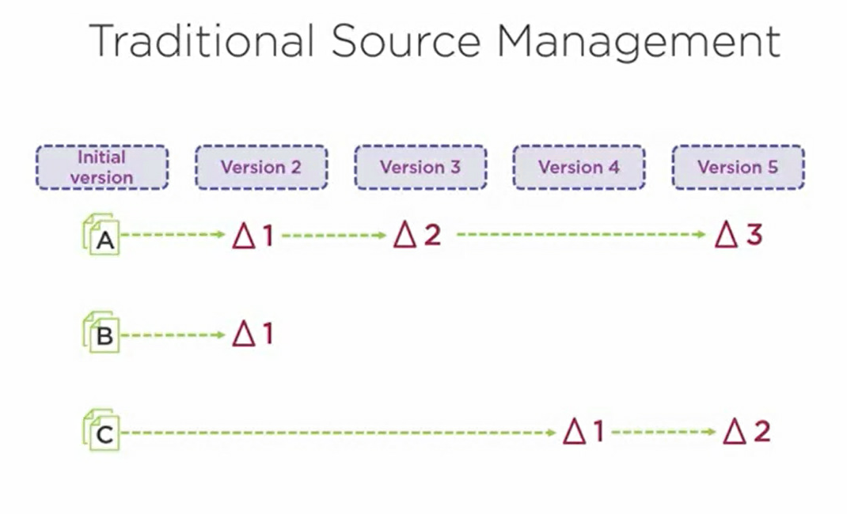

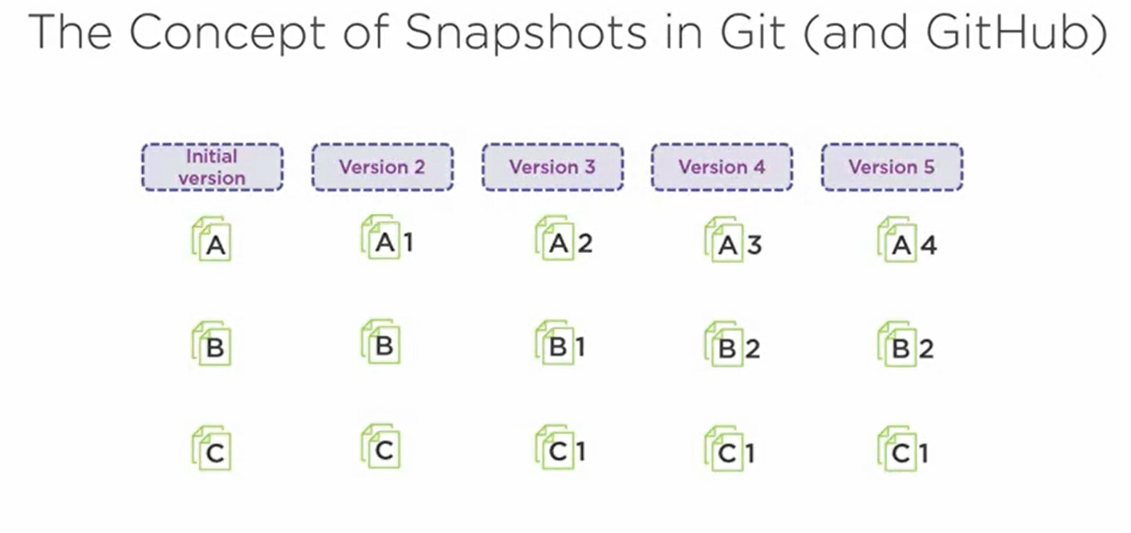

Branch is a pointer to a commit

The Commands for Branching

$git branch [branch- name]

$git checkout [branch- name]

$git push –u [Original branch- name] [NewBranch name]

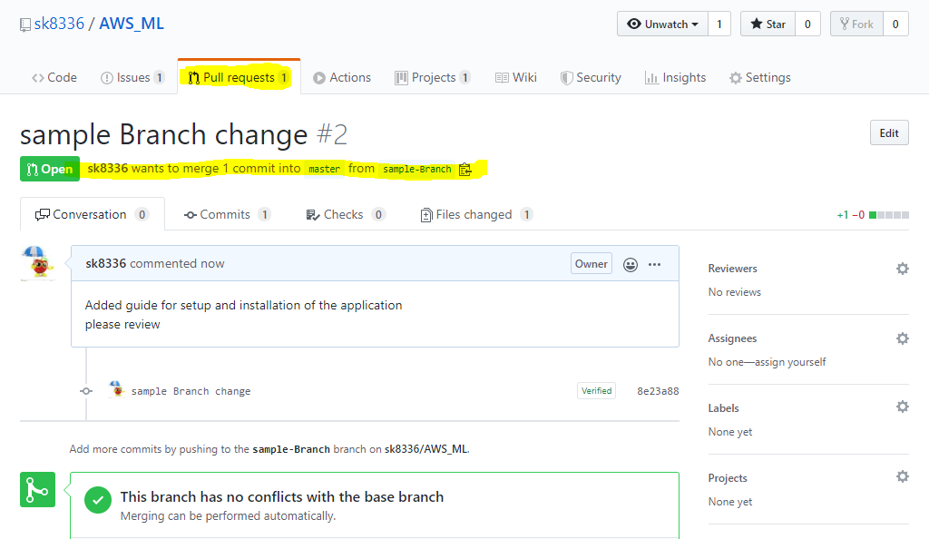

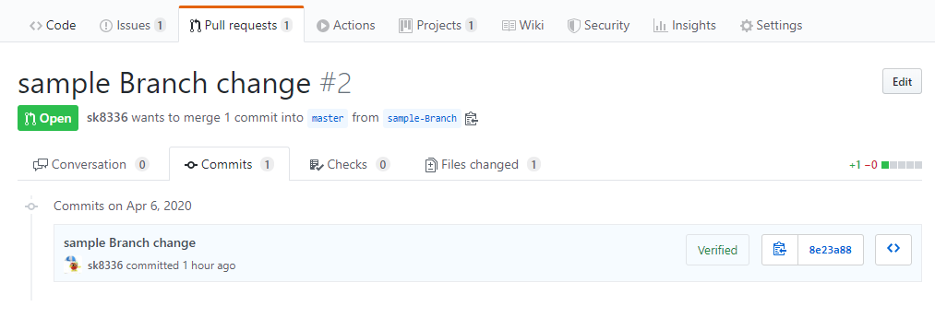

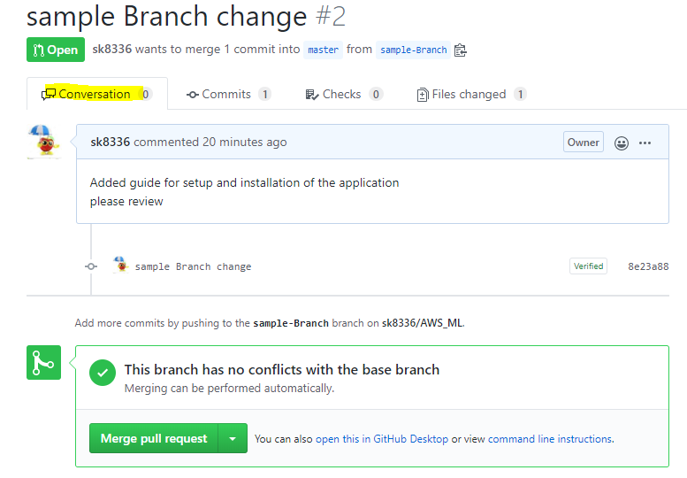

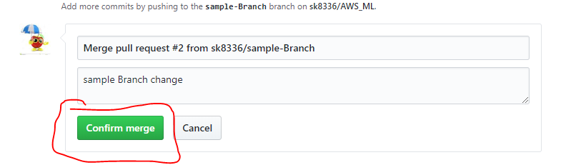

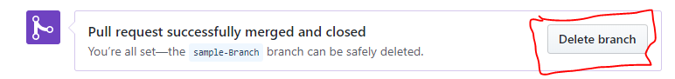  
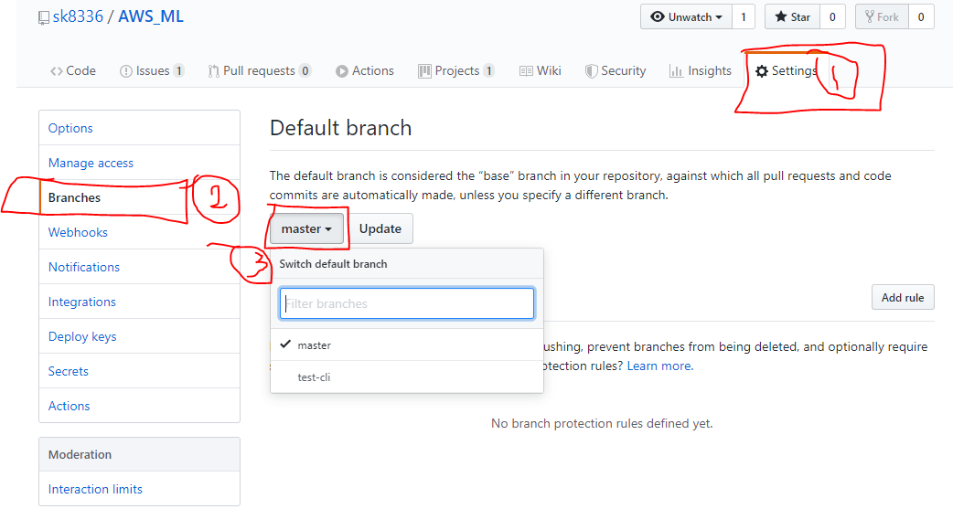

Create Tag and Releases

A tag points to an important point in history V1.0

2 types of tags:

Light weight

Annotated (Message and checksum

Command : $ git tag

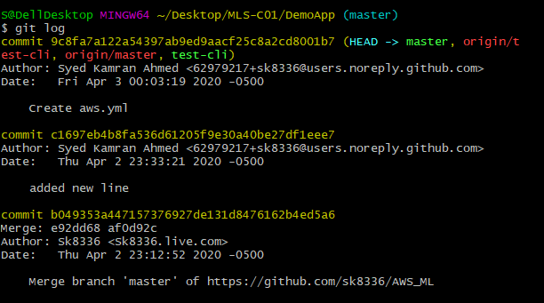

Log command shows all commit

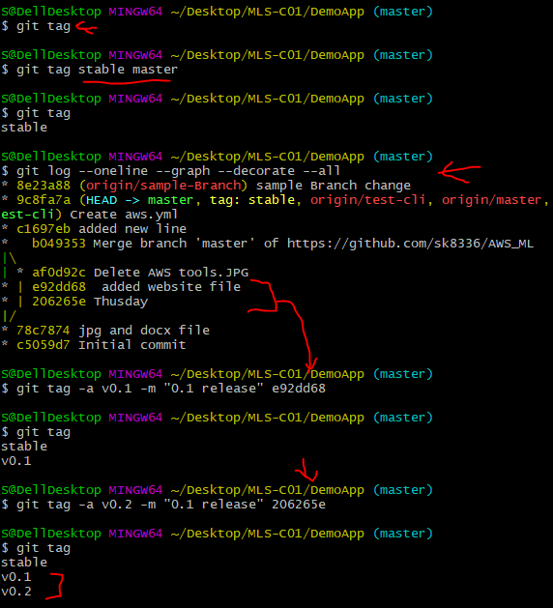

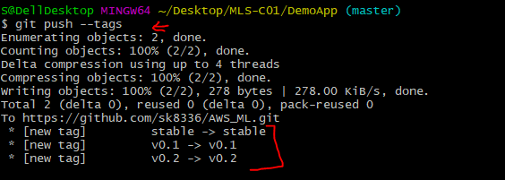

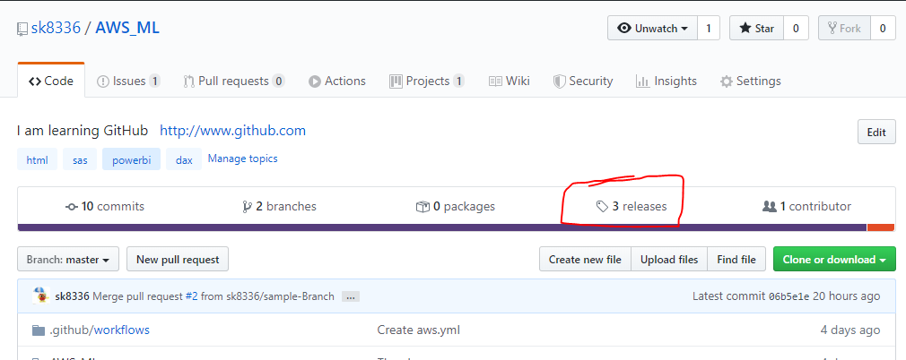

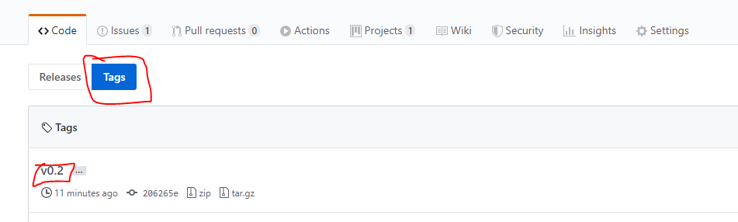

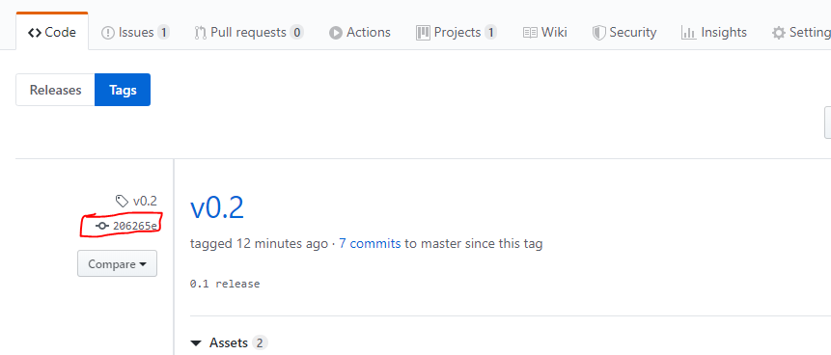

Delete tag and push

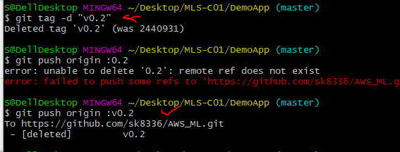

Release

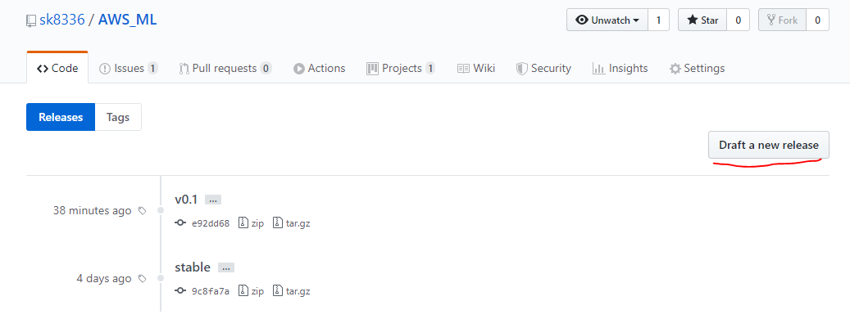

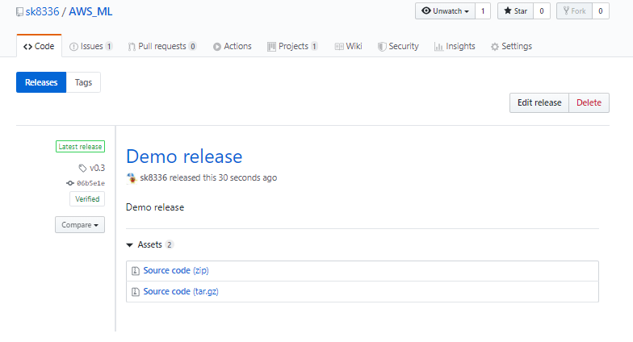

CH7

Forks is the copy of repo

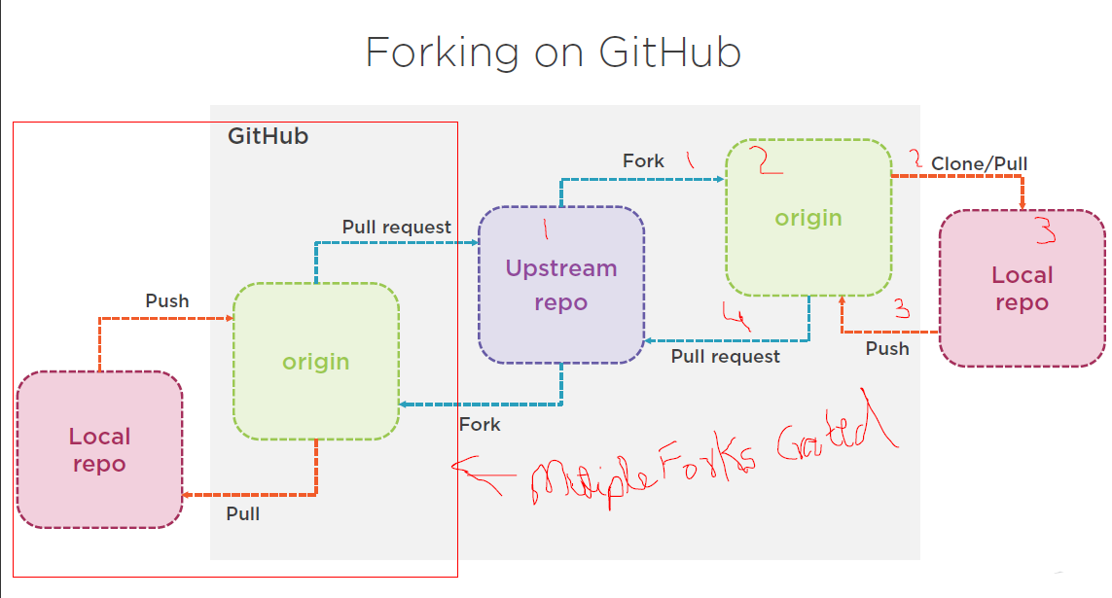

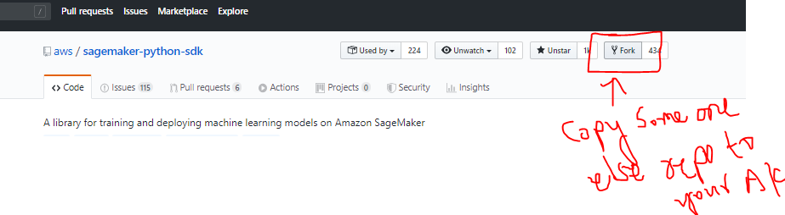

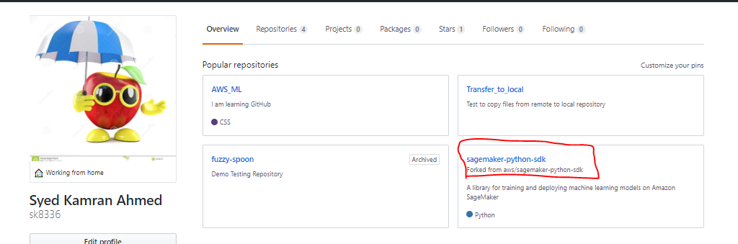

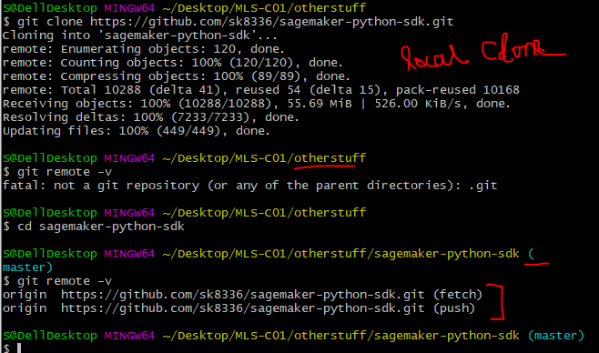

Gist:

Gist is a simple way to share snippets and notes with others

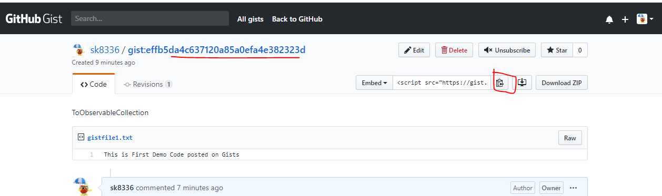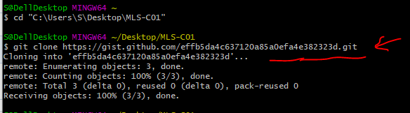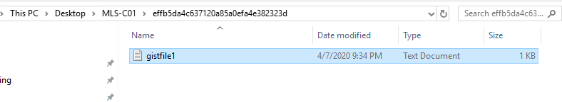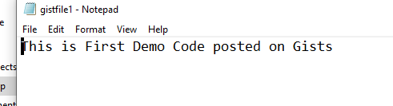

Page - Setting

